

Global Markets Equity

DbX Margin Redesign: Development of dbX 2.0

Design Document

Name of Project: Margin calculation based on approved “Rules of the Road” Margins
Project ID: TBD

Date Prepared: Feb 2009
Document Version: 1.0

Table of Contents
1. DOCUMENT CONTROL 3
1.1 Change History 4
2. INTRODUCTION 5
2.1 Purpose 5
2.2 Scope 5
2.2.1 Solution Statement 5
2.3 Change Description 5
2.3.1 Business and Operations Process 5
2.4 Target Audience 8
2.5 Problem Statement – Stakeholders Need 9
2.6 Applications Impacted 9
2.7 Structure and Use 9
2.8 Traceability 9
2.9 Disclaimer 9
3. GENERAL INFORMATION 9
3.1 Challenge/Opportunity 9
3.2 Feature/Project Description 10
3.3 Benefit/Value 10
3.4 Assumptions, Dependencies, Constraints 10
3.5 Security Risk Assessment 10
4. SYSTEM ARCHITECTURE 11
4.1 Hardware Requirements 11
4.2 Software Requirements 23
4.2.1 Software engineering Environment 23
4.2.2 Software Engineering Test Environment 23
4.2.3 Software Development Library 23
4.2.3 Software Development Files 24
5. IMPLEMENTATION 25
5.1 Input and Output Layer Design 25
5.1.1 Client Information table 25
5.1.2 INPUT Table 25
5.1.3 OUTPUT Table 30
5.1.4 Backtracking: The Linkage Error! Bookmark not defined.
5.2 Rehypothecation 34
5.2.1 Rehypo Definition 34
5.2.2 Rehypo Table: t_rehypo_config 34
5.3 Margin Calculation 34
5.4 Caching 39
5.4.1 Proposed Caching Mechanism Error! Bookmark not defined.
5.4.2 Cache Table(s) Error! Bookmark not defined.
6. FEED STRUCTURE 43
6.1 Feed Outline 43
6.2 Schedule 43
7. Appendix 44
7.1 Current Logic with known shortcomings 44

1. DOCUMENT CONTROL

Document History

Version No. | Author | Description | Date
1.0 | Jilei, Ashutosh & Mandeep | Initial Draft | Feb. 2009
1.1 | Rajneesh and Jilei | Second Draft | Apr. 2009

This section lists the details of the reviews for this document

Version No. | Name of Reviewer | Role | Date
1.0

1.1 Change History

Version  No. | Details of Change | Changed Sections | Prepared by | Date
1.0

2. INTRODUCTION

2.1 Purpose
dbX margin system provides cross product margin functionality for our clients. This document is to detail the redesign of dbx margin calculation engine using JEE technology.

This document serves as basis line that can be reviewed and agreed upon between technology and business clients.

Also senior management can use this document to measure the risk, benefit and progress.

2.2 Scope

2.2.1 Solution Statement

Demand and expectation of business clients for dbX system have increased dramatically in last few years, especially in the current uncertain market condition. The current production is an aged system, build on top of a combination of Unix shell and Perl scripts, running the datasynapse platform. The current system cannot meet the business needs within the timeframe proposed by the clients. Based on the technology it uses, the system lacks of scalability, flexibility, which are vital to our continuous business growth. Also, the current system cannot take full advantage that modern grid computing platform offers. It is difficult if not possible to thoroughly handle exception, resolve resource contention, and maintain data integrity. It takes great effort to continuously support and maintain the system, to meet ever increasing business demand to customize margin rule for different clients.

Using mainstream matured J2EE technology, the dbX2 margin calculation engine will adopt the principle of Service Oriented Architecture to ensure a wide audience can leverage the benefit provided by the new system. The new architecture will also minimize resource contentions, while maximize stability, scalability, flexibility, and traceability. Based on the new technology, the dbX2 system will build a solid foundation for future rapid development and ease the report generation.

2.3 Change Description

2.3.1 Business and Operations Process
The new margin calculation engine should not disturb any current existing business and operation processes, while provides new functionality such as

1. Dynamically change margin process for a particular legal entity without redeploying.
2. Provide What-If scenario analysis
3. Intra-day position and security tracking to fully back each margin report produced during the business day.

2.3.1.1 Technical Changes

Figure 1 below, shows the high level view of the dbX 2.0 application modules. Data collection, Margin Calculation and Reporting have been divided into three separate modules, so that they can be modified individually, if there is a need at any point in future, with no impact to the other. This document will focus on module 2.

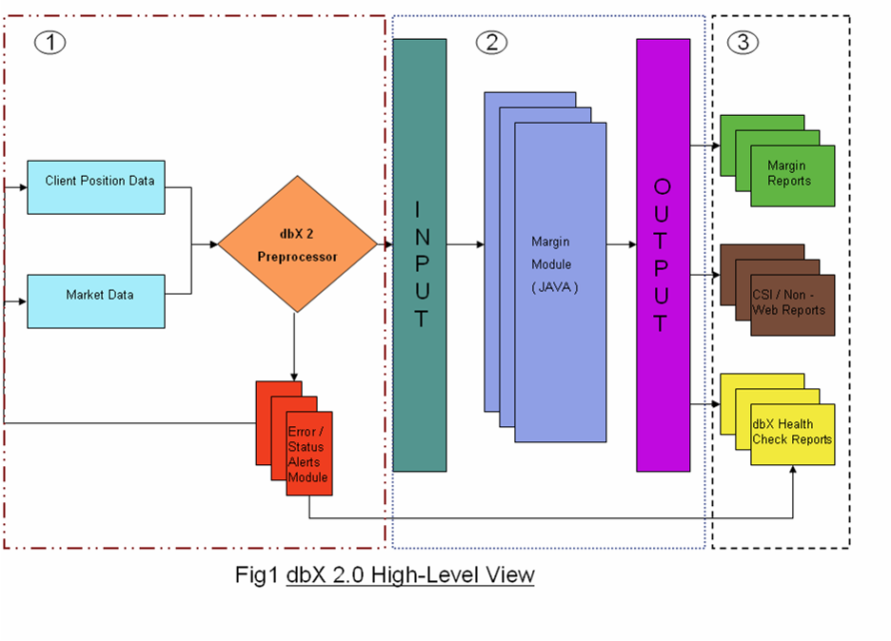

2.3.1.2 Architecture Overview

The major shortcomings of current dbX system are listed below. At the same time, these are the most important design objectives for dbX2.

Flexibility

The tightly coupled and highly interdependent design makes enhancing current system a very labor intensive task. Almost all non-trivial requests require complete regression testing to ensure there is no negative impact of the change, which is a very time-consuming process.

Transparency and Consistency

The current system does not provide all detailed information to backup its margin results. And the drill-down position information could be out of synchronization with the margined positions. Also from time to time, web page display different security information from what is used in the margin process.

From production support’s perspective, it is hard to tell status of margin refresh batch. We have to look at datasynapse admin console and run sql query at database to know the status.

Integrity

Due to technology chosen for the current system, such as BCP, Perl, Unix Shell, and their limitation, it is very difficult to maintain data integrity in the current system.

Scalability

The current system heavily uses temp tables and stored procedures on Sybase database server. It makes the database a bottle-neck resource. Simply investing in new hardware, putting more datasynapse engine will only improve response time for individual margin request. This approach will not shorten the batch margin refresh time when system is fully loaded.

dbX2 will address these concerns by

- Leverage cache mechanisms offered by datasynapse to ensure the consistency of security information across the platform. This cache is distributed, fully synchronized and high-performance.

- Introduce a separate persistent tier based on hibernate to ensure data integrity.

- Build a façade in the database to encapsulate current complicated logic scattered everywhere in stored procedures. This façade will give us flexibility from database perspective. We add one more database xmagin in our Sybase server to implement the façade and store intermediate margin results. The façade will also ease report development.

- Fully utilize the flexibility derived from Spring framework and load the spring bean container at legal entity level to ensure each legal entity is customizable without interfering each other.

- Embed a beanshell engine in the margin calculation system to “factor out” high volatile business requirement while the requirement is under most intense change. The script engine combined with AOP mechanism provided by Spring framework, gives us flexibility, which business demands, to dynamically customize margin process on each client basis.

- Fully utilize the exception mechanisms offered by JEE and datasynapse to ensure end-to-end error handling. Ensure all errors are visible on the GUI.

- Decompose margin strategy into a list of reusable statistics collection and a list of rates lookup or scenario components. Each component is figured using Spring framework. A strategy provides some glue logic to connect each rates lookup or scenario components. This approach will lay a solid foundation to launch agile development in the future.

- Instead of trying to combine multiple legal entities together to form a task on grid engine, the dbX2 keeps a task to its smallest unit, which is one legal entity, to ensure scalability.

- Provide a new margin rate control tier at security level for each client. It means, beyond legal entity level margin rate customization, we have a much fine grain control on margin rate.

- Implement a service scheduler to clearly tell the status of batch process (start, end, failed, etc) and each single refresh request.

A high level architecture diagram

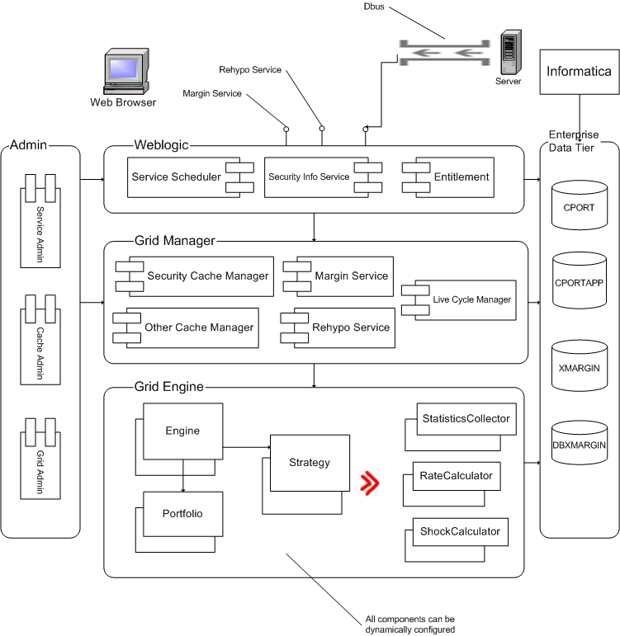

2.4 Target Audience

The target audience for design document is
- DBX Development team
- Risk team
- Senior managers

2.5 Problem Statement – Stakeholders Need

The needs are as follows -:

- Flexibility for customized margining process for any individual client.
- Thorough error handling to ensure the data integrity is always maintained.
- What-if/Impact Analysis
- Transparency, margin results are fully explained in detail, with all the supportive statistics.
- A single GPF source for data quality and consistency.
- Real time feed and process capability.
- Increase in number of reports, with reduced reporting time and development effort.
- Scalability for performance

2.6 Applications Impacted

While the design goal is to minimize the impact to the downstream systems, which are using sql statement to directly pull data from dbX system, there will be some change in the current database, which may impact down stream systems, although we don’t expect any big impact in the first stage.

2.7 Structure and Use
<Doc structure>

2.8 Traceability
< Tracking of changes>

2.9 Disclaimer
- Due to the resource and timeframe constrain, we are not going to overhaul the web interface in the first stage and leave it to the second stage. The consequence of this decision is that we have to build an adapter to feed new margin data into existing web related tables.
- We decide not to use a full-blown rule engine available on market and not going to build one in house. The concern is the performance and flexibility limitation inherited from the rule engine.

3. GENERAL INFORMATION

3.1 Challenge/Opportunity

- A single GPF source for data quality and consistency.
- Real time feed and process capability
- Reduction in query time
- Increase in accuracy
- Increase in number of reports.
- Application scalability for performance

3.2 Feature/Project Description

3.3 Benefit/Value

3.4 Assumptions, Dependencies, Constraints

3.5 Security Risk Assessment

4. SYSTEM ARCHITECTURE

4.1 Margin Domain Model Overview

This section describes the domain model used for computing margins on the positions in client portfolios. The model captures the relevant components that participate in the margin computation process. Figure xx represents the structural relationships between the components and interfaces. This domain model tries to accurately represent the rules based margining paradigm as set forth in the “Approved Rules of the Road Margins” reference model. The margining process will consist mainly of the following phases:

- Client/Legal Entity portfolio initialization for margining
- Margin methodology initialization for the client
- Margining of the portfolio by applying a client specific margin methodology consisting of a set of margin rules
- Persisting margin results for display, reporting and margin explanation

Client/Legal entity portfolio initialization- Before margining all portfolio related data for the client must be collected from persistent storage, this includes the following:

- Credit profile for the client
- Positions held by the client
- Margin Rates loaded by margin rate manager.
- Securities traded for each position

Margin Methodology initialization – Each client can be configured or associated with a specific margin methodology as defined by the business. Margin methodologies consist mainly of a set of margin strategies that are operated on in sequence to compute the margin values for each position in the portfolio. See Approved “Rules of the Road” reference manual for the defined margin strategies and the rules comprising each strategy.

Portfolio margining – After initialization is complete for the portfolio and margin methodology, the portfolio can be margined by applying the methodology across the positions in the portfolio. Each type of margin methodology defines how its strategies are applied to the portfolio positions to compute the overall margins.

Persisting margin results – In order to explain the margining process and provide reporting features for users, all intermediate results during margining is captured in persistent storage. The following information is captured for later use cases:

- Margin positions, these are master records that contains detail margin positions which indicates how position amounts were distributed during the margin process.
- Detail margin positions, contains the details of the distribution of position amounts to each margin strategy
- Margin results, contains the actual margin amount for each position

4.2 Margin Domain Model

The following diagram depicts the margining domain model necessary to support the computation of margins applicable to client portfolios. A description of each component and how it participates in the model follows:

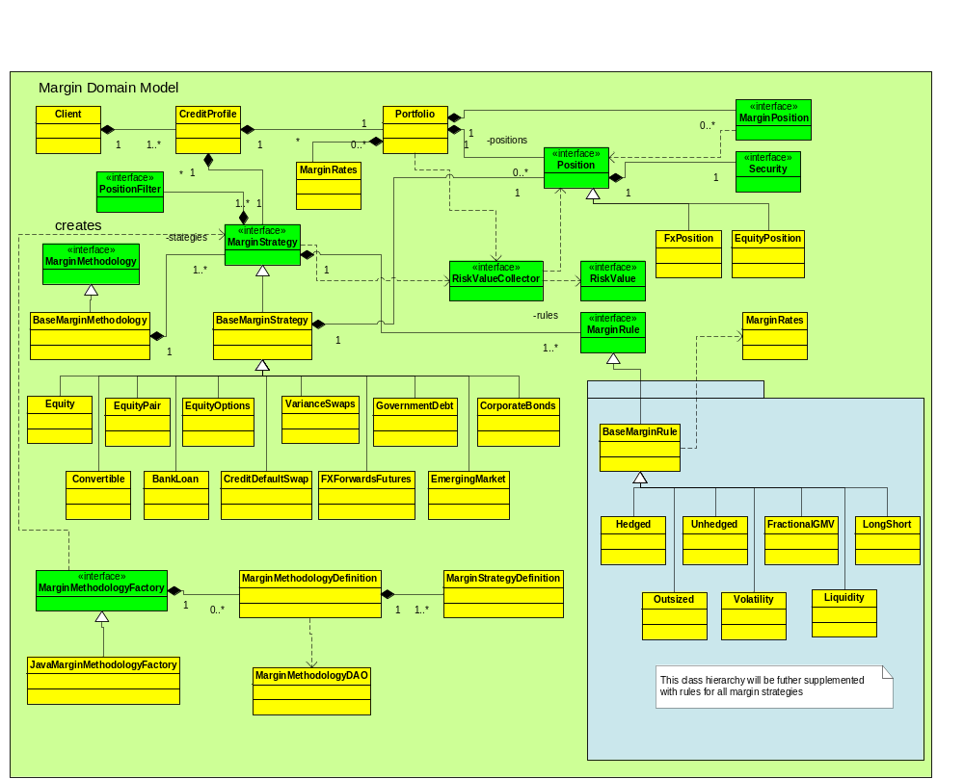

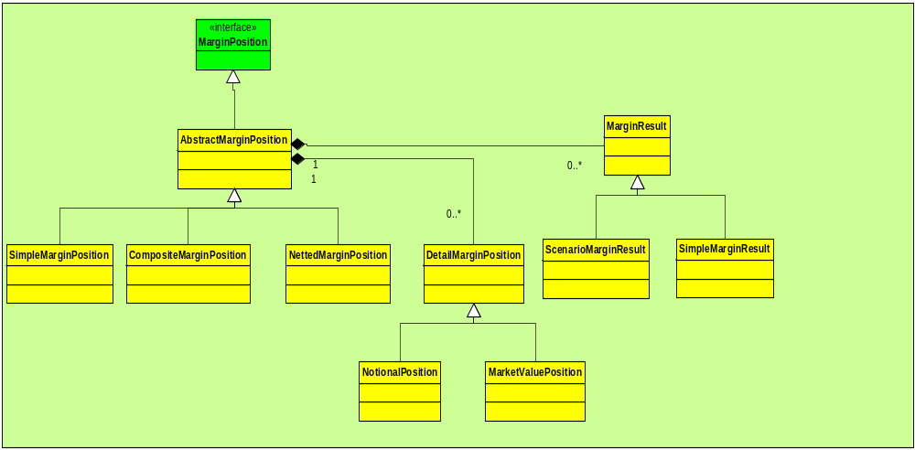

Figure xx Margin Domain Model

4.2.1 Client
The Client component is intended to represent a real world business client or legal entity. The informational content of the Client will consist mainly of a CreditProfile and the Portfolio of positions.

4.2.1.1 Client Component Description

Class | Client
Purpose | Represents a legal entity to the margin system
Use
Inherit
Implements
Attributes | Signature | Meaning
Functions | Signature | Meaning

4.2.2 CreditProfile

4.2.2.1 CreditProfile Component Description

Class | CreditProfile
Purpose | Maintains the legal entity credit profile for margin purposes.
Use
Inherit
Implements
Attributes | Signature | Meaning
1..1 | int legalEntityId | Legal entity identifier
Functions | Signature | Meaning
1..1 | int getLegalEntityId | Get the identifier for the legal entity

4.2.3 Portfolio
A portfolio represents the ensemble of positions which are held by the Client/Legal Entity.

4.2.3.1 Portfolio Component Description

Class | Portfolio
Purpose | Maintains the positions for a client/legal entity
Use
Inherit
Implements
Attributes | Signature | Meaning
0..* | List<Position> positions | List of positions for the legal entity
1..* | List<MarginRate> marginRates | List of margin rates applicable for the legal entity
1..1 | CreditProfile getCreditProfile | The credit profile for the legal entity
0..* | List<MarginPosition> marginPositions | List of margined positions generated after magin process.
Functions | Signature | Meaning
0..* | List<Position> getPositions | Get and unmodifiable list of the positions in the port
0..* | List<Position>filterPosition(PositionFilter) | Filters the portfolios positions using the specified position filter.
1..1 | Portfolio filterPortfolio(PositionFilter) | Create a new portfolio consisting of a subset of the original portfolio positions
1..1 | CreditProfile getCreditProfile | Get the credit profile for the legal entity
0..* | List<MarginPosition> getMarginPositions | Get the list of margined positions after margining
1..* | List<MarginRate> getMarginRates | Get an unmodified list of margin rates for the legal entity
 | addMarginPosition(MarginPosition) | Add a new margined position to the portfolio
0..* | List<Position) getUnmarginedPositions | Get unmodifiable list of positions that have not been margined for the portfolio.
1..1 | RiskValueContainer CollectRiskValue(RiskValueCollector) | Collects risk values from the portfolio using the specified risk value collector

4.2.4 Position
The position component represents an investment in a single security either long or short. These positions are consolidated by the Portfolio.

4.2.4.1 Position Component Description

Class | Position
Purpose | Represents an invested quantity (long or short) in a particular security
Use
Inherit
Implements
Attributes | Signature | Meaning
1..1 | Int legalEntityId | Identifier of the legal entity that owns the position
1..1 | Int securityId | Identifier of the position’s security
Functions | Signature | Meaning
 | Int getLegalEntityId | Get the id for the legal entity owner
 | Int getSecurityId | Get the security identifier for the position
 | Double getAmount | Get the position amount

4.2.5 MarginPosition
The MarginPosition component represents the computed margin values for a position in the client portfolio. Each position in the portfolio contributes a MarginPosition to the portfolio. The margin position constitutes a

4.2.5.1 MarginPosition Component Description

Class | MarginPosition
Purpose | Maintains results of the margin process for each position
Use | Container for computed margin results and break down of margin details
Inherit
Implements
Attributes | Signature | Meaning
0..* | MarginResult marginResults | Computed margin values for a position
0..* | DetailMarginPosition marginPosition | Master detail breakdown of the position margining.
Functions | Signature | Meaning
0..* | List<MarginResult> getMarginResults | Get the computed margin results for the margin position
0..* | List<DetailMarginPosition> getMarginPositions | Get the margin position details

4.2.6 PositionFilter
The PositionFilter provides an interface that allows the user to filter the set of positions contained in a portfolio. Concrete implementations of PositionFilter supply the selection criterion that is used to filter the portfolios positions. Margin strategies will implement the position filter in order to obtain a sub-portfolio consisting of the relevant positions.

4.2.6.1 PositionFilter Interface Description

Class | PositionFilter
Purpose | Specifies an interface that allows users to select positions within a portfolio
Use | Used by clients to create subsets of the legal entity positions in the portfolio
Inherit
Implements
Attributes | Signature | Meaning
Functions | Signature | Meaning
0..* | Boolean filterPosition(Position) | Returns true if the position should be removed from the set, false if it should be selected.

4.2.7 MarginMethodology
MarginMethodology represents a container for a specific set of margin strategies. The methodology defines the execution sequence for the Strategies it contains.

4.2.1.1 MarginMethodology Component Description

Class | Client
Purpose | Provides a container and execution context for a set of margin strategies.
Use
Inherit
Implements
Attributes | Signature | Meaning
Functions | Signature | Meaning
 | Void calc | Executes the contained set of margin strategies in sequence.

4.2.8 MarginStrategy
A MarginStrategy defines the set of margin rules applicable to specific security types.

4.2.1.1 MarginStrategy Component Description

Class | Client
Purpose | Defines the set of margin rules applicable to specific security types.
Use
Inherit
Implements
Attributes | Signature | Meaning
Functions | Signature | Meaning
 | Void calc | Computes margin position by applying the margin rules to the positions

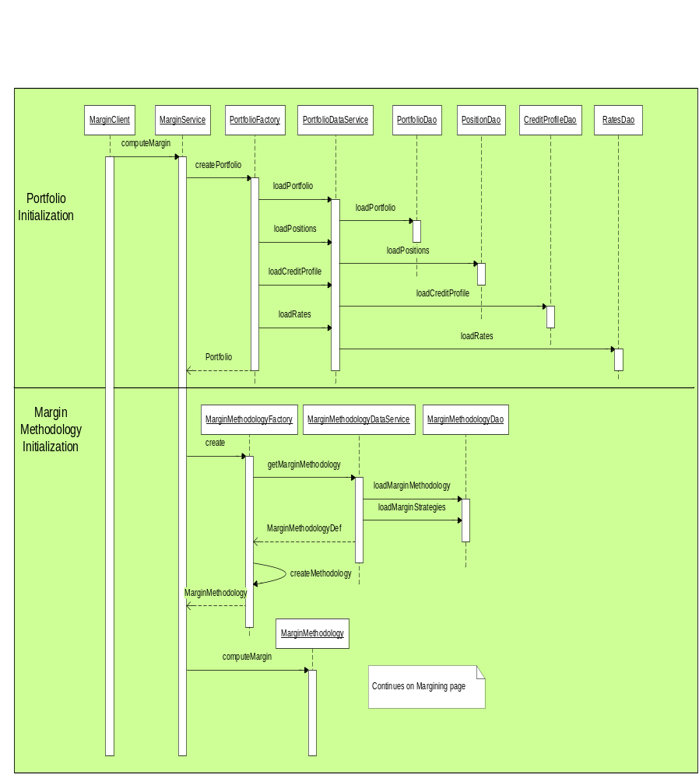

Figure xxx Margining Initialization Sequence Diagram

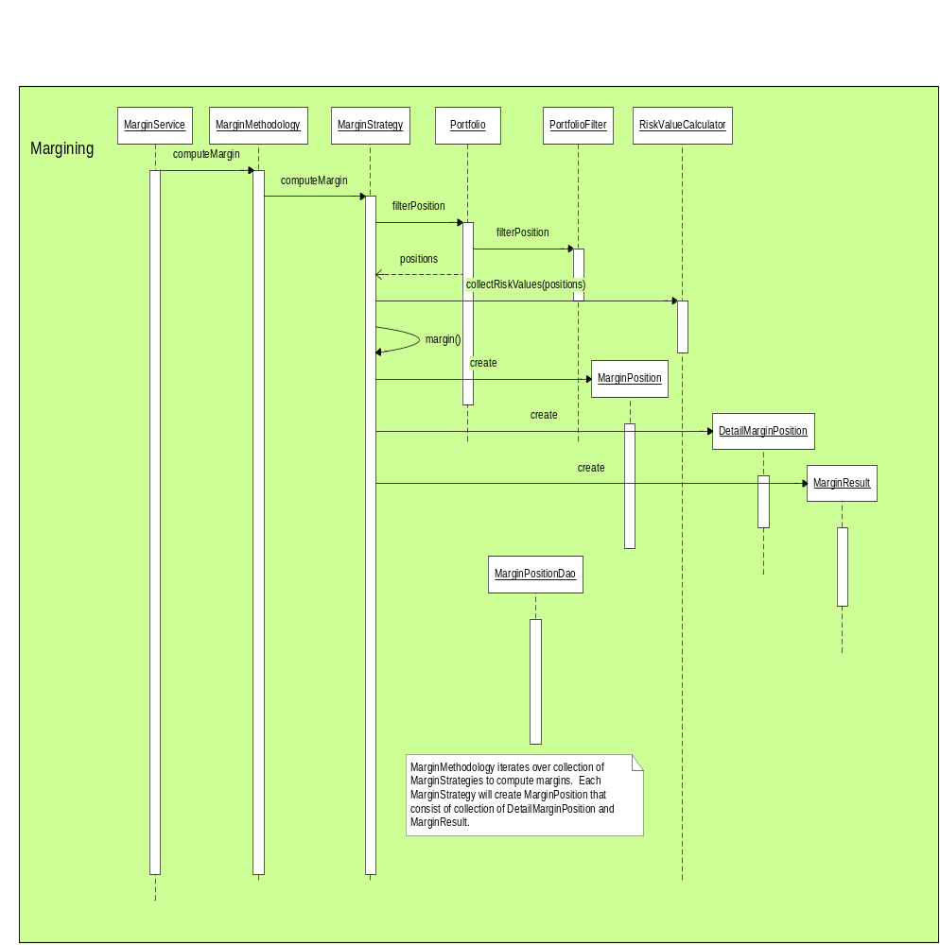

Figure xxx Margining Sequence Diagram

4.3 Margin Override Framework

Users will have the ability to override the properties of positions that are margined. The following framework will generically allow margin overrides for any property of the positions that are margined.

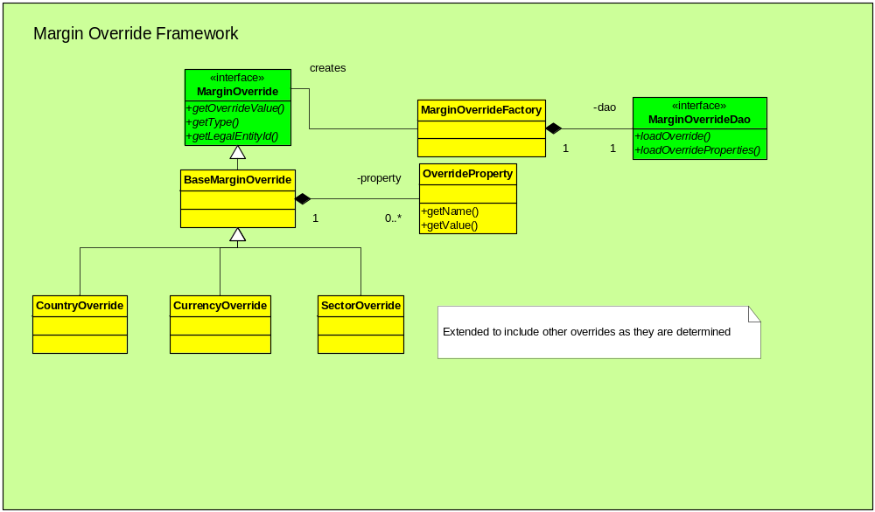

Figure xxx Margin Override Framework

4.3.1 MarginOverride
This component specifies the interface used to access margin overrides generically. The various override types defined in the database is created in specific override types eg. CountryOverride and accessed through this interface.

4.3.1.1 MarginOverride Component Description

Class | MarginOverride
Purpose | Provides a generic interface for accessing the various margin override types that are defined.
Use | Polymorphic access to margin override types
Inherit
Implements
Attributes | Signature | Meaning
1..1 | int overrideType | The specific type of the override
1..1 | Int legalEntityId | Identifier for the legal entity
1..1 | Double overrideValue | The value of the override
Functions | Signature | Meaning
1..1 | Int getLegalEntityId | Get the identifier for the legal entity
1..1 | Int getOverrideType | The the type for the override
1..1 | Double getOverrideValue | Get the amount of the override
0..* | List<Property> getProperties | Get the list of properties defined for the override.
1..1 | Property getProperty(String name) | Get the specified property by name

4.4 Data Access Object Design Pattern
This section describes a generic facility for defining and implementing the various data access objects for DBX. Figure xxx outlines the general pattern. Each domain business object will delegate data access to its data object. The data object will encapsulate data retrieved from the data source via the relevant data access object (DAO). Data access objects will be implemented via stored procedures or JDBC SQL.
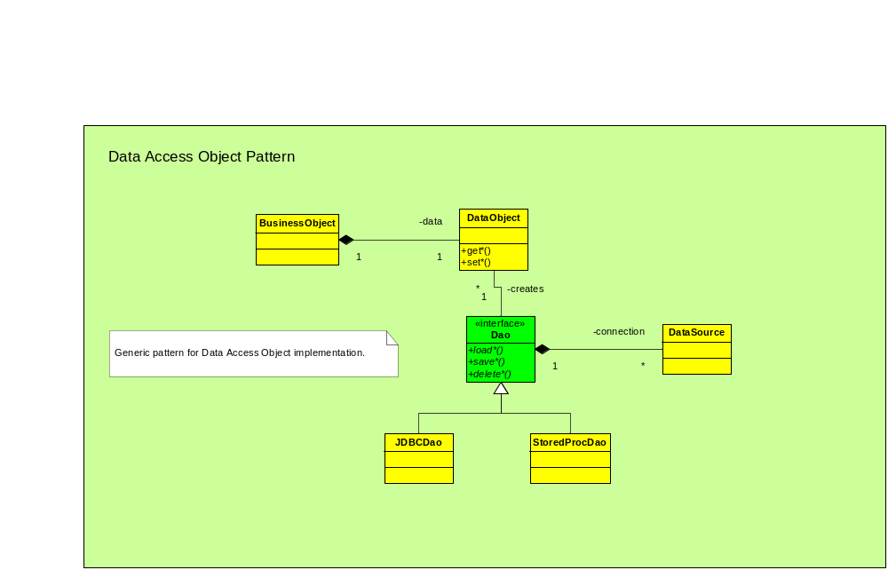

4.4.1 BusinessObject
BusinessObject generically represents any domain object in the system that has a persistent state in the database. BusinessObjects maintain a reference to its corresponding data object.

4.4.2 DataObject
DataObjects are the data containers for business objects. They maintain the persistent state of business or reference model objects in the database. Data objects are created by data access objects (DAO) which knows how to fetch data from the database.

4.4.3 DAO
It is the responsibility of DataAccessObjects to query persistent storage in order to retrieve the state for DataObjects. DataAccessObjects maintains a DataSource connection to the persistent storage.

4.4.4 DataSource
A DataSource represents the information relevant to make connections to some persistent storage, eg. A Sybase database. A DAO uses the datasource to connect to the database in order to retrieve the state for DataObjects.

4.5 DataService Design Pattern
The DataService design pattern provides a mechanism for consolidating access to data sources. Because of the massive parallel and distributed nature of the grid infrastructure it is infeasible to have each grid node connecting to the database server. The data service concept allows for the reduction of connections to the database and at the same time provide for load balancing and failover of each data service.

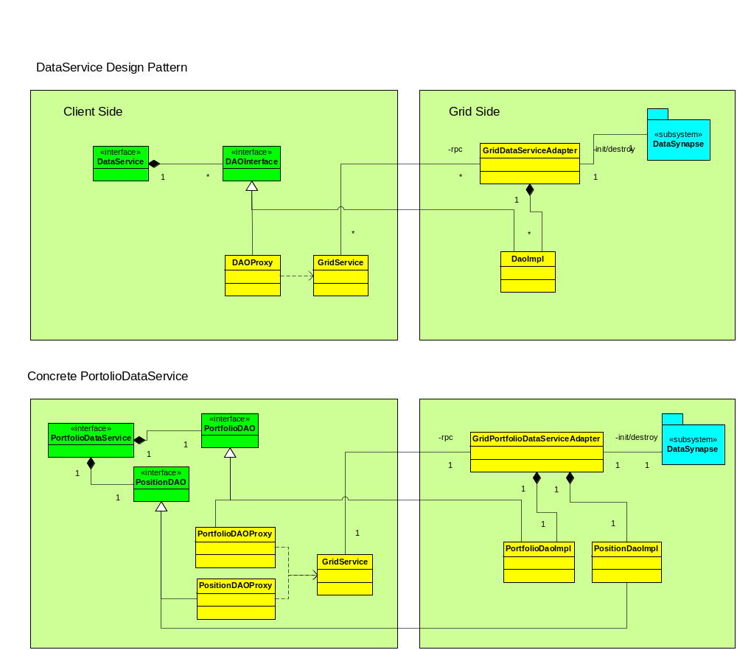

Figure xxx DataService Design Pattern

4.5.1 DataService
The DataService provides a façade that accesses the methods of the various DAO injected within it. It is a client side proxy for the grid data service that provides access to the actual DAO implementations.

4.5.2 DAOProxy
DAOProxy represents a client side proxy for a remote DAO that performs the physical access of the data. Access is accomplished through the GridService object, which is responsible for forwarding requests to the GridDataServiceAdapter.

4.5.3 GridService
The GridService object implements the invocation mechanism to execute synchronous and asynchronous request on the grid. It provides a wrapper for the DataSynapse grid service.

4.5.4 GridDataServiceAdapter
The GridDataServiceAdapter is responsible for receiving request from remote clients and dispatching to the appropriate DAO implementation.

4.6 Software Requirements

4.6.1 Software engineering Environment
Development tools to be used for dbX2 consists of

- IDE: Eclipse: 3.4.1
- JDK: 1.6 update 11
- JDBC: jconn3.jar
- Spring: Spring 3.1
- Hibernate: 3.4.1
- DataSynapse GridServer: Grid Server 5
- Weblogic: Weblogic 10
- Log4j:
- JUnit: 4.4
- Ant:

Runtime Technology Stack:
- JRE 1.6
- Control-M
- DataSynapse GridServer: Grid Server 5
- Weblogic: Weblogic 10
- Spring Framework: 3.1
- Hbernate: 3.4.1

4.6.2 Software Engineering Test Environment

The developer shall establish, control, and maintain a software test environment to perform qualification, and possibly other, testing of software. The developer shall ensure that each element of the environment performs its intended functions.

4.6.3 Software Development Library

4.6.3.1 Document Library

The document library, located at \\10.158.175.98\dbX2\design consists of all specifications, manuals, documents, other reports, etc related to DBX2 project.

4.6.3.2 Software Program Library

<TBD>

4.6.3.3 Correspondence & Reference Library

<TBD>

4.6.4 Software Development Files

4.6.4.1 Software Development File Approach

Package Structure:

Package | Comments
com.db.dbxmargin.gridserver.cache | grid cache manager
com.db.dbxmargin.gridserver.hook | grid server life cycle management
com.db.dbxmargin.portfolio | model legal entity position and setting
com.db.dbxmargin.security | model security
Com.db.dbxmargin.domain | model country, currency, etc.
com.db.dbxmargin.engine | margin engine
com.db.dbxmargin.strategy | margin strategy
com.db.dbxmargin.service | internal access point
com.db.dbxmargin.dao | database access and persistent tier
Com.db.dbxmargin.client | a driver to launch service
com.db.dbxmargin.util | dbx utility
com.db.dbxmargin.exception | dbx exception derived from RuntimeException

Additional Packages:

Package | Comments
com.db.dbxmargin.tester | testing driver

4.6.4.2 Software Development File Format
<TBD>

4.7 Hardware Requirements
< Rajneesh to add this>

Disk Space on database server:

5. IMPLEMENTATION

5.1 Database façade

We build a façade layer in our database to insulate margin calculation engine. This segregation will ensure engine will remain intact while data feeds adapt new changes from outside world. Also this separation greatly simplifies the interface between engine and rest of database.

5.1.1 Client Information
Currently client information is stored in many tables. And the logic to collect and use this information is scattered all over the system. We need to have an interface table to shield the complicated relationship and logic between following tables:

- CR_LegalEntity
- CR_LegalEntityAlias
- CR_Group
- CR_GroupMember
- CR2_LegalEntityMapping
- CR2_LegalEntityAlias
- CR_Product
- ROR_GroupAllocation

5.1.1.1 Table: t_entity_alias
This table stores the latest client information from margin’s perspective. This table will drive all margin calculation and detail drill-down on the web interface.

PK | Column name | Type | Nulls | Default
Yes | legalEntityId | Int | No
Yes | accountId | Int | No
 | productId | Int | No
 | inactiveInd | Tinyint | No
 | margined | Tinyint | No
 | Process_Date | Smalldatetime | No
 | reportingCcy | Char(3) | No
 | useCR2 | Tinyint | No
 | accountType | Smallint | No
 | Allocation | Float | No | 1.0
 | parentId | Int | No

In the first stage, we refresh each legal entity and store information in this table in the beginning of margin calculation. In the second stage, this table will be in-sync with base tables in real-time.

5.1.1.2 Stored procedure: p_refresh_entity_alias

This stored procedure centralizes the logic used in the current system from margin’s perspective.

5.1.2 Position Information
Current dbX platform does not store the position, security information used margin engine, along with the margin results. This not only brings complexity for the reporting, but also makes the tracing back of the intraday margin fluctuations almost impossible. Sensitive clients, that do not want their margin reports to be rerun after certain time in a day, always have difficulty to get a break-up on the position and margin level, as things may have been changed because of an updated data or position feed.

The proposed solution is to persist the snapshot view of the input and output information. The approach will also benefit, but not limited to, what-if scenarios analysis, client based customization, checking intra day margin anomalies, generating change reports, ad-hoc reports etc. Overall idea is to have a functionality to be able to go back in time for any type of assessments.

A high level of ER Diagram:

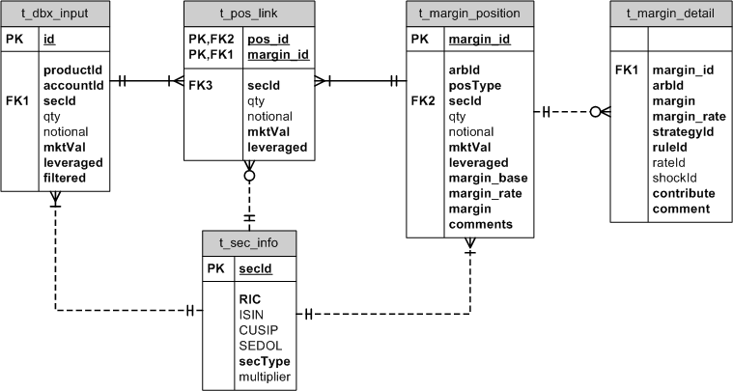

5.1.2.1 Position Table Design

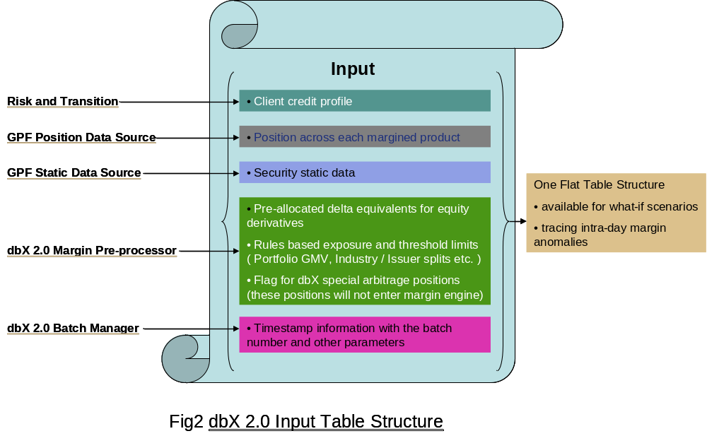
Position table definition of t_dbx_input

Column Name | Type | Remark
Id | Int | PK
legalEntityId | Int
batchId | Int | PK
Timestamp | datetime
accounted | Int
productId | Int
processDate | Smalldatetime
reportingCcy | Int
secId | Int
positionType | varchar(2) | To tell what position it is, i.e. security pos, cash pos, etc.
settleCcy | Int
settleCost | Float
settleFx | Float
settleQuantity | Float
settleMktValue | Float
tradedQuantity | Float
tradedMktValue | Float
tradedCcy | Int
tradedCost | Float
localCcy | Int
localFx | Float
Multiplier | Float
mktPrice | Float
Bid | Float
Ask | Float
initialMargin | Float
Pl | Float
dividendAccrued | Float
interestAccrued | Float
Div01 | Float
swapNo | Int
swapMtm | Float
isSwapCcyName | Int
buyCcy | Int
Sellccy | Int
sellQuantity | Float
buyQuantity | Float
buyFx | Float
sellFx | Float
tradeId | Varchar(40) | Trades identifier
Gmv | Float | Contribution to portfolio GMV. Delta equivalent.
Filtered | tinyint | =1 means not going to engine
Restricted | Int
isNonleverage | char(1)
isNonFinanced | char(1)
Date1 | smalldatetime
Date2 | smalldatetime
Strid1 | Varchar(40)
Strid2 | Varchar(40)
Numid1 | Int
Numid2 | int
Term1 | float
Term2 | float
syntheticId | Int | Default is 0
rptStrategyId | Int

This table will also persist synthetic position generated by margin process.

Security table definition: t_sec_info:

Column Name | Type | Remark
secId | Int | PK
batchId | Int | PK
Timestamp | datetime
RIC | Varchar
ISIN | Varchar
SEDOL | Varchar
CUSIP | Varchar
Sec_Name | Varchar
Sec_Ccy | Varchar
secType | Int
Underlying | Int
underlyingRIC | Int | Underlying RIC
Multiplier | Float
activeFlag | Tinyint
countryId | Int
industryId | smallint
subSectorId | smallInt
sectorId | smallint
volatility | float | From APT
riskVolatility | float | From BB
volume | float
outstandingAmount | float
issueAmount | float
duration | Float
coupon | float
worldBeta | Float
usBeta | Float
issuer | Varchar
conversionRatio | Float
parValue | Float
cashSpread | float
PIKSpread | Float
seniority | Varchar
tranche | Varchar
spread | Float
delta | Float
Rho | Float
vega | Float
gamma | Float
theta | Float
beta | Float
riskCountry | Varchar (2) | Risk country
riskCountryDebtTier | int
riskCountryEquityTier | int
riskVolume | Float
riskOutstanding | Float
riskSecType | int
subRisksecType | int
isWorthless | int
isMajorIndex | int
isMinorIndex | int
isADR | int
mktPrice | float | Market price
floatingRate | Float
isLive | int
dbMarketLoan | Varchar
maturity | datetime
rating | Varchar
ratingId | int
convertibleNow | int
isPrivate | Int
isTrsloan | int
isDistressed | int
underaWnAmt | Float
TotalDebtOutstandingIssuer | Float
mark | Float
callput | int
strike | Float
impVol | int
underSecType | smallInt
underExchange | Varchar
underDescription | Varchar
underCurrency | int
underCusip | Varchar
contract | Float
optType | int
xrate | Float
deriveAe | int
classType | int

We also consolidate multiple loading logics to one stored procedure: p_load_position.

5.1.3 Margin Result Tables
The margin result tables, together with the input tables defined above, provides and end-to-end, detailed, and solid margin story for clients. They will greatly enhance the transparency.

Core Margin Result table: t_margin_position

CREATE TABLE dbo.t_margin_position
(
id int NOT NULL,
legalEntityId int NOT NULL,
batchId int NOT NULL,
Process_Date smalldatetime NOT NULL,
source varchar(16) NOT NULL,
marginReq float NOT NULL,
marginBase float NOT NULL,
marginRate float NOT NULL,
marginComments varchar(256) NULL,
strategy tinyint NOT NULL,
rptStrategy tinyint NOT NULL,
hedged char(1) DEFAULT 'N' NULL,
overridden char(1) DEFAULT 'N' NULL,
linkId int NOT NULL,
secId int NULL,
reliefId int NULL,
reliefRate float DEFAULT 0 NULL,
posType char(1) NOT NULL,
timestamp datetime DEFAULT getdate() NOT NULL,
CONSTRAINT pk_t_margin_position
PRIMARY KEY NONCLUSTERED (batchId,id)
)

The relationship between margin position and input position tables is many-to-many relationship. So we introduce a link table as:

CREATE TABLE dbo.t_input_link
(
linkId int NOT NULL,
batchId int NOT NULL,
inputPosId int NOT NULL,
amount float NOT NULL,
marginBase float NOT NULL,
hedged char(1) DEFAULT 'N' NULL,
rptStrategy tinyint NOT NULL,
CONSTRAINT fk_input_link
FOREIGN KEY (batchId,inputPosId)
REFERENCES dbo.t_dbx_input (batchId,id),
CONSTRAINT fk_margin_link
FOREIGN KEY (batchId,linkId)
REFERENCES dbo.t_margin_position (batchId,id)
)

All the margin detail happen during margin process is captured in

CREATE TABLE dbo.t_margin_detail
(
detailId int NOT NULL,
batchId int NOT NULL,
marginPosId int NOT NULL,
ruleId int NOT NULL,
rateId int NULL,
shockId int NULL,
marginReq float NOT NULL,
marginBase float NULL,
marginRate float NULL,
marginComments varchar(128) NULL,
strategy tinyint NOT NULL,
contribute char(1) DEFAULT 'Y' NULL,
detailType char(1) NOT NULL,
CONSTRAINT pk_t_margin_detail
PRIMARY KEY NONCLUSTERED (batchId,detailId),
CONSTRAINT fk_margin_position
FOREIGN KEY (batchId,marginPosId)
REFERENCES dbo.t_margin_position (batchId,id)
)

It supports two kinds of detail type from margin calculation’s point of view.

- Regular detail ,such as industry add-on, referred by rateId.

- Scenario detail, it tracks margin requirement for each scenario, referred by shockId.

Because we use hibernate to facilitate OR mapping, we favor a table for each class hierarchy. Parallel to t_margin_detail, t_margin_position supports two types SimpleMarginPosition and SetMarginPosition in Java class type. Please refer Component design sector for more detail.

SimpleMarginPosition aggregates the same security across different products, while SetMarginPosition supports a mini-portfolio, such as all options for one underlying and their related underlyings. Please refer Component design sector for more detail.

The support detail for margin results is stored in the t_margin_statistics.

CREATE TABLE dbo.t_margin_statistics
(
id int NOT NULL,
batchId int NOT NULL,
strategy tinyint NOT NULL,
stats_name varchar(64) NOT NULL,
stats_key varchar(32) NOT NULL,
field varchar(32) not null,
number float NULL,
CONSTRAINT PK_statistics
PRIMARY KEY NONCLUSTERED (batchId,id)
)

It is a vertical table, so it can be used to store any numeric supportive information.

5.1.4 Configuration Tables
To support flexibility required by business, we build a generic configuration table in the database. Parallel to the single inheritance adopted by Java, our configuration in database is also inheritable. Configuration in the system naturally forms a hierarchy tree, so that we can organize the configuration in a meaningful way from business’ perspective.

CREATE TABLE dbo.t_config
(
configId int NOT NULL,
type char(1) NOT NULL,
config text NULL,
p_id int NOT NULL,
CONSTRAINT PK_config
PRIMARY KEY NONCLUSTERED (configId)
)

p_id points to its parent configuration.

In the first stage, we put two kinds of configurations in this table

- Spring configuration to customize margin methodology.
- Beanshell scripts to customize client’s data attributes

We can easily introduce new configuration in the future whenever we see fit.

All configurations are at legal entity level to ensure segregation between clients.

CREATE TABLE dbo.t_entity_config
(
legalEntityId int NOT NULL,
port_bean varchar(32) NULL,
engine_bean varchar(32) NULL,
config_id int default 0 NOT NULL,
script_id int default 0 NOT NULL,
CONSTRAINT PK_config
PRIMARY KEY NONCLUSTERED (legalEntityId)
)

Supported by the data in this table, each legal entity can have its own spring configuration and scripts, if we choose to. Margin engine uses the bean names supplied from this table to launch calculation.

5.1.5 Rate Exception Table
We will reuse current margin rates table and discount set table. However, dbX2 will provide a fine-grain margin rate exception mechanism at security level per client.

CREATE TABLE dbo.t_margin_exception
(
legalEntityId int NOT NULL,
secId int NOT NULL,
rate_id float NOT NULL,
rate_type char(1) NOT NULL,
lbound float NULL,
ubound float NULL,
rate float NOT NULL,
expiration_dt smalldatetime NULL,
last_mod datetime NOT NULL
)

Together with the current tables, dbX2 will have a much detailed and uniform control at margin rate.

5.1.6 Use Case for database design

Sample dbX Client : A B C Partners LLC
Position Feed
Ticker | Source | Account Code | Market Value $
ABC.D | Global PB | GPB_1 | -40
ABC.D | Global PB | GPB_1 | -30
ABC.D | US Swap | USS_1 | 30
ABC.D | Global PB | GPB_2 | 100
ABC.D | UK Swap | UKS_1 | -40

Exposure netted across products
Ticker | Exposure Type | Value $
ABC.D | Position from PB | 30
ABC.D | Position from Swap | -10
ABC.D | Netted Position | 20

Case 1 : Only Swap is financed and No leverage for PB
Margin Split
Ticker | Margin Description | Mkt Value $ | Margin Rate | Margin $
ABC.D | Margin as per Equity Rules | -10 | 50% | 5
ABC.D | No Leverage | 30 | 100% | 30
 | Total Margin | 20 | 175% | 35
Case 2 : PB and Swap gets cross margined in dbX
Margin Split
Ticker | Margin Description | Mkt Value $ | Margin Rate | Margin $
ABC.D | Margin as per Equity Rules | 20 | 50% | 10
 | Total Margin | 20 | 50% | 10



5.2 Rehypothecation
<Wen to provide this>

5.2.1 Rehypo Definition

5.2.2 Rehypo Table: t_rehypo_config

Column Name | Type | Remark
legalEntityId | Int
traderId | Int
productId | Int
isUSPB | Int
Rehypothecation | Int
interCcyCRsIncluded | Int
nettablesCcyCRs | Int
includeSwapMargin | Int
includeSwapMTM | Int
netCRagainstSMV | Int
crHaircut | Int
debit | Int
shortMktValue | Int

5.3 Security Cache

Currently, dbX system keeps security information in several flat files on NFS according to security type. It needs to re-generate whole file even if there is one change in one security.

In dbX2, we will leverage the global distributed cache mechanisms provided by Datasynapse platform. We will put all security information in uniform cache indexed by dbX internal security id.

Following is a high level system diagram for Datasynapse distributed cache.

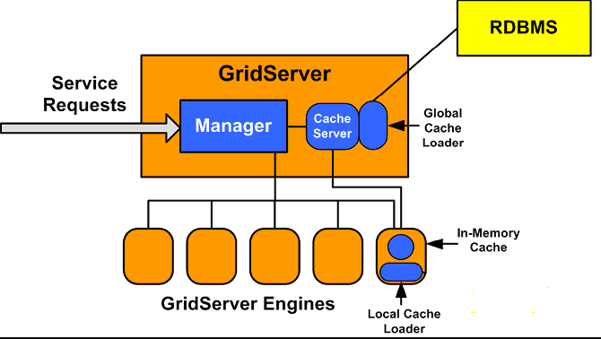

5.3.1 Cache Loading Strategy

The loading process consolidates current security refresh logic, which are scattered in several places into a single place. It first find all security identities currently has position in the system and load all security attributes, which will impact margin calculation.

Datasynapse will be responsible to load whole security cache once Datasynapse server is up, through Datasynapse server life cycle management.

Security Class Diagram:
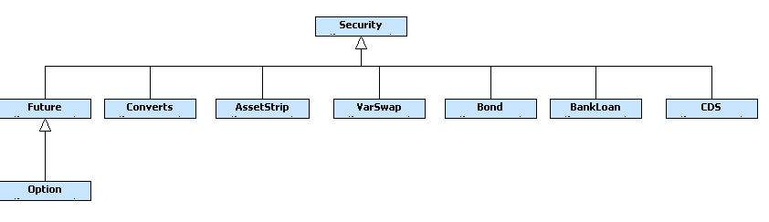

5.3.2 Cache Invalidate/Refresh Strategy

We will add a timestamp column in our security master table in our database. And

- Schedule a looping thread hosted in Weblogic server constantly checking if a security has been updated since last loop according to its timestamp. The process will gather all updated/new securities and load them into Datasynapse’s cache. The timestamp could be updated by application or support team.

- Margin process running on the grid engine will gather all missing securities during position loading and submit to cache server to invoke the security cache loader to load these securities.

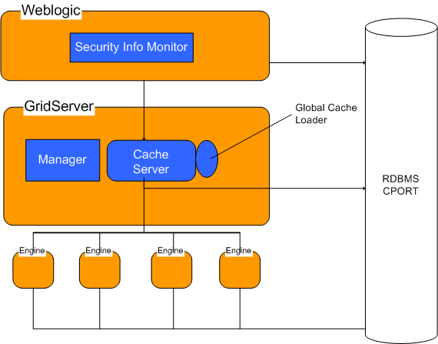

At the second stage of this project, we will implement:

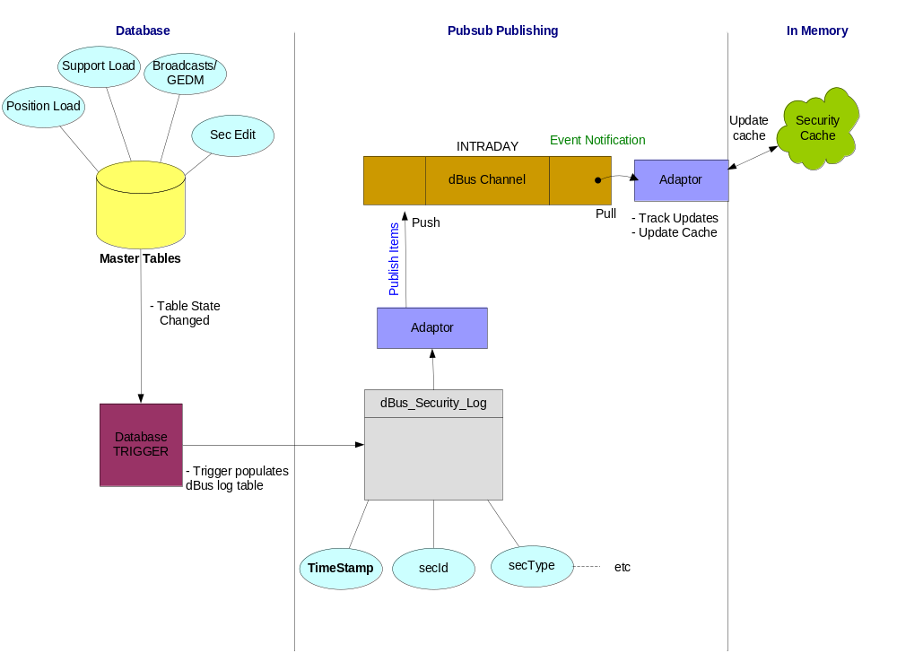

5.3.3 Cache Retrieve Strategy

At portfolio level, we have a security cache manager, acting as a proxy to global security cache. Before and after requesting security information from cache server on the grid manager, the local cache manager checks if there is any override exists for this portfolio.

This two-tier structure ensures us the flexibility we need.

5.3.4 Other caches

In dbX2, we have other caches for information, such as country, currency, fx rate, CDS suppression, etc. The implementation is similar to the solution described above.

5.4 Margin Calculation

5.4.1 Margin Service Entry Point

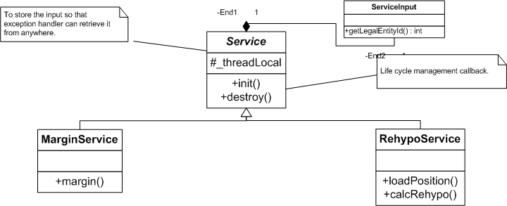

5.4.2 High Level Sequence of Margin Process and Class Diagram
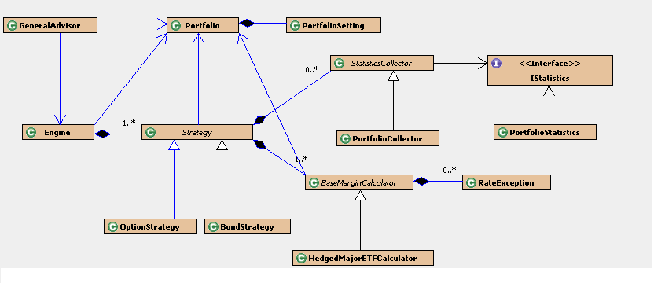
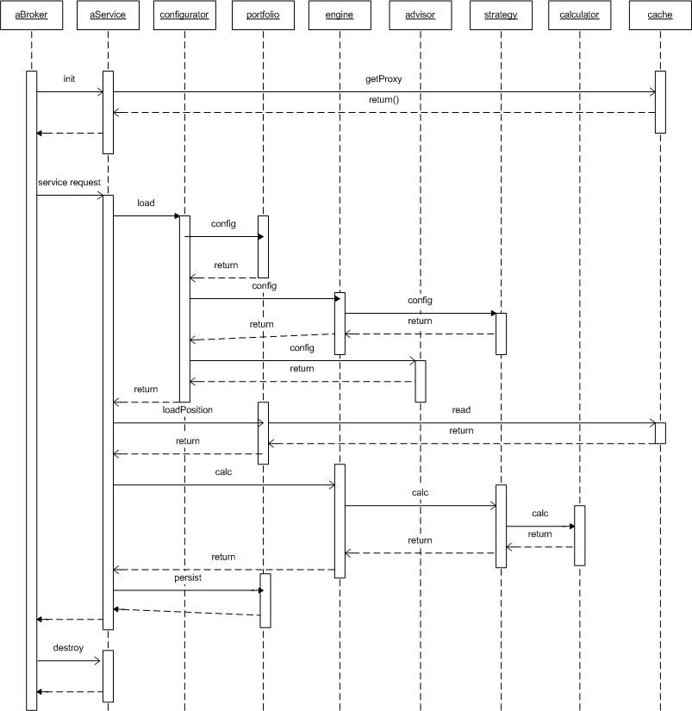

5.4.3 PortfolioSetting – a portfolio configurator
Service delegates portfolio and margin configuration to this object. This class loads Spring container according to client’s configuration.

Life span: service task

Multiplicity: one object per one client (a.k.a. portfolio)

Attributes:
Engine bean name
Portfolio bean name
List of spring configuration id
List of scripts id

Major method:
Portfolio loadPortfolio();
Engine loadEngine();
Advisor loadAdvisor();

5.4.4 Portfolio
This class models client’s portfolio positions and its specific setting. Configured by Spring, implements interfaces IAdvisable and ApplicationContextAware.

This class also has a list of StatisticsCollector to collect number at portfolio level.

This class also holds margin results. It is a data holder.

Life span: service task

Multiplicity: one object per one client.

Attributes:
_secManager: SecurityManager a proxy to global cache manager on grid cache server.
_persister: access point to persistent tier
_positions: List of positions
_results: list of margin results

Major methods:
Void refreshAccountMapping()
Void loadPosition()
Void persist()
Void overrideMargin();

5.4.5 Engine
This class models the margin methodology. Configured by Spring, implements interfaces IAdvisable and ApplicationContextAware.

This class holds a list of margin strategy. It is not a data holder. Its object is stateless.

Life span: service task

Multiplicity: one object per one client.

Attributes:
_strategies: List<Strategy>

Major methods:
Void calc(Portfolio port)

5.4.5 Strategy
This is a root abstract class. All margin strategy classes are meant to derive from this class. Configured by Spring, implements interface IAdvisable and ApplicationContextAware. Its object is stateful. It also holds a list statistics collector and a list of margin calculators.

Multiplicity: multiple objects per an engine.

Attributes:
_collectors: List<StatisticsCollector>
_calculators: List<IMarginCalculator>

Major methods:
Abstract Public List<InputPosition> collectPosition();
Abstract Public Void calc();
Abstract Public void genReport();

Public void collectStatistics();

The sub class of Strategy is meant to implement calc(), where some simple logic to mediator margin calculators and invoke them according to the specific business logic.

5.4.6 Margin Calculator
The root is an abstract class BaseMarginCalculator. It implements IAdvisable and ApplicationContextAware .

Any concrete class, which extends this class, has to implements:

public MarginDetail margin(AbstractMarginPosition mpos, Strategy strategy);

It represents a single margin rule. It could be a set of margin rate lookup tables or a single rate lookup. Also it could be a set of shocking scenarios some option positions should go through.

This class loads the margin override on the security and rule basis. It provides a finer grain opportunity to do margin rate override.

Function margin() returns NULL if the margin rule is not applicable to the position.

5.5 Data Structure for Margin Result

5.5.1 High level class diagram
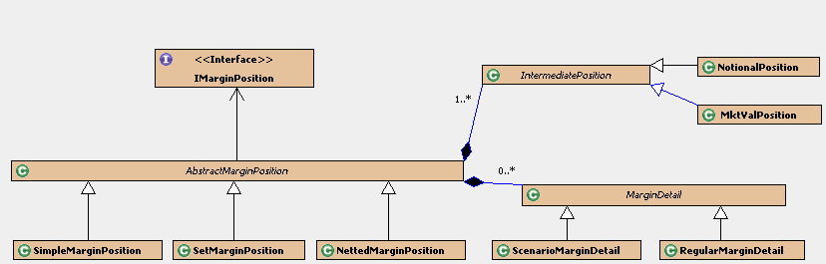

5.5.2 AbstractMarginPosition -- Center of structure
This is a root abstract class implements IMarginPosition. It represents an indivisible position or a set of positions meaningful to the calculation engine.

Margin position has a many-to-many relationship to InputPosition. The link is represented by IntermediatePosition. An IntermediatePosition object stands for a portion (maybe whole) InputPosition. One MarginPosition object can have a list of IntermediatePosition objects.

IntermediatePosition has two concrete classes. One is NotionalPosition, used to presents CDS position, which is margined on notional basis. The second one is market value position, used to presents Equity, Bond, etc, which are margined on market value basis.

5.5.3 SimpleMarginPosition
This class extends AbstractMarginPosition. It represents an aggregation of one single security. This class is used by strategies, such as bond, long/short balance, etc.

5.5.4 SetMarginPosition
This class extends AbstractMarginPosition. It represents an aggregation of multiple related securities. This class is used by strategies, such as option, pairs, etc.

5.5.5 NettedMarginPosition
This class extends AbstractMarginPosition. It represents an netted position. Any object of this class has 0 margin requirement. Any strategy will generate Netted position before it does any real calculation.

5.5.6 MarginDetail
This is an abstract root class, to represent a detailed margin requirement, such as industry penalty, issuer concentration penalty, etc. It has two concrete classes. One is the RegularMaginDetail, used to represent bond base rate, industry penalty, etc. The second one is ScenarioMarginDetail, used to represent margin requirement based on certain scenario. The objects of this class are generated by option, and VolArb strategies.

This class belongs to margin position.

5.6 Persistent Layer

We use hibernate to persist our data into database.



6.1 Feed Outline

6.2 Schedule

7. Appendix

7.1 Current Logic with known shortcomings

Current DBX logic is based on the following steps. . .
- First, collect all the static data.
- Second, collect all the position data.
- Map position data with static data and then
  - Assign strategy to each mapped element
Problem:
    - No customization allowed at this level. Whenever there is a change, the securities mapped to strategy are routed somewhere else and identified as “specials”
  - Push the new object to the pre-defined GRID into common array elements.
Problem:
    - Pre-defined grid makes it inflexible and there is a chance of missing data.
    - With “common array element” logic, individuality is lost as all the positions get merged into one common structure.
  - Split objects from “Common Array Element” by strategies. This is done one by one.
Problem:
    - No intelligence checking and decisions not made on client requests.

In short, current DBX system is based on doing things in predefined way giving no user/client flexibility.

